
FACULTY OF INFORMATION TECHNOLOGY
2025 DATABASES 600
ASSIGNMENT
richfield.ac.za

Name and Surname: Matthew Magadza

Student ITS No: 402310062

Qualification: BSCIT Year of Study: 2025 Semester: 1

Assignment due date: Date submitted:

QUESTION | EXAMINER MARKS | MODERATOR MARKS | REMARKS
ASSIGNMENT INSTRUCTIONS
Please tick each box to confirm completion. (10 Marks)
Use Times New Roman font, size 12, with 1.5 line spacing throughout the document. Apply Harvard Referencing Style for all citations and references.
For essay-style assignments, please include the following sections:
Table of Contents Introduction
Main Body (with relevant subheadings) Conclusion
References
Submit the assignment in PDF format on Moodle. Use the specified cover page provided.
Include a signed declaration of originality.

DECLARATION OF ORIGINALITY:
I hereby declare that this assignment is my own work and has not been copied from any other source except where due acknowledgment is made. I affirm that all sources used have been properly cited and that this submission complies with the institution’s policies on academic integrity and plagiarism.

Student Signature: MTM Date:

Richfield Graduate Institute of Technology (Pty) Ltd is registered with the Department of Higher Education & Training as a Private Higher Education Institution under the Higher Education Act, 1997, Registration Certificate No. 2000/HE07/008.

QUESTION 1 (30 MARKS)

  - Richfield Consulting recently hired you as a graduate database developer. They’re upgrading their data storage from a manual paper-based system to a digital DBMS. As a graduate developer, critically discuss the difference between a paper-based system and a digital DBMS, furthermore, highlight the components, functions as well as the pros and cons of a DBMS.
QUESTION 2 (30 MARKS)

  - Provide the necessary SQL code to create a table named Student, with columns as shown in
Figure 1. Ensure that the columns have appropriate data types. (5)
Figure 1: SQL Table

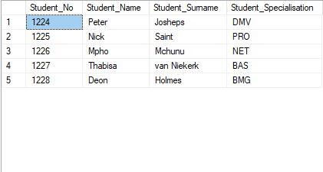
  - Provide the necessary SQL code to insert the data as indicated in Figure 2 (5)
Figure 2: SQL Table with data

  - Provide the necessary SQL code to insert a record with your name, surname, 9999 as the student
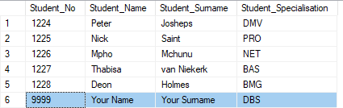
number, and DBS as the specialisation. (5)
Figure 3: SQL Table with custom data

  - Provide the necessary SQL code to change the Student_Surname for Thabisa from van Niekerk to
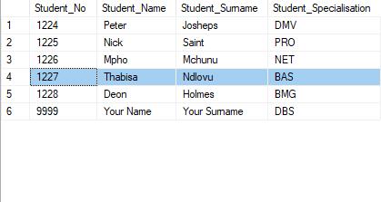
Ndlovu. (5)
Figure 4: SQL Table with updated values

  - Provide the necessary SQL Code to change the Column name ‘Student_Specialisation’ to Student Module (5)

  - Provide the necessary SQL code to delete the Student table as well as the database the table is stored in. For this question, assume the Student table is stored in a database named School. (5)
QUESTION 3 (30 MARKS)

  - TechGen is upgrading their database from an excel spreadsheet to an RDMBS. They have given you the following business rules. A store can have many employees but only one manager. An employee must be a Technical Assistant or Desktop Technician. A manager can be a store manager

or a departmental manager. There can only be one store in one location, and each store can have up to three (3) departments only.
Draw the EERD for TechGen and indicate multiplicity / cardinality (where applicable) as well as the common attributes in each table. (15)

  - Consider the following report below. Convert the report into a set of BCNF tables (if possible). Fully describe each step and clearly show relation schema.

STUD_NO | STUD_NAME | STUD_SNAME | QUAL_ID | QUAL_DESC | FINAL_PROJ | PROJ_NAME
1125 | Marco | Polo | 1 | Degree,  Undergrad | Required | 3rd Year  Project
5541 | Jason | Statham | 2 | Higher  Certificate | Not Required
6687 | Ben | Grimm | 1 | Degree,  Undergrad | Required | 3rd Year  Project
2551 | Peter | Parker | 3 | Diploma | Required | 3rd Year  Project
6669 | Thando | Wolff | 5 | Honours | Required | Research  project
8879 | Theodore | Jacobs | 8 | MBA | Optional

(15)

*******************************************************END********************************************************

